msr

PROCESS MANAGER

INTRODUCTION

The purpose of this training course / workshop is to describe the facilities available within the Process Manager component of the SITS:Vision software. The objective of this course is to gain an understanding of the data structures within Process Manager and to set up reusable template processes.

By the end of the course, delegates should have developed skills to apply these processes within their working environment.

COURSE TOPICS

The topics covered by the course include:

• Object (OBJ) and Object Instance (OBI)

• Activities (OBA) and Triggers (OBT)

• Participants (OBP) and Resources (OBR)

• Template Processes

• Task Manager Interaction (pre-requisite course SVT604 Intray Messaging)

• Process Manager Standard Letters and Reporting

COURSE STRUCTURE

The course is structured into xxx sessions. The sessions will vary in length according to the complexity of the topic.

Session 1

• Course Introduction
• What is Process Manager?

Session 2

• The Object (OBJ) table
• The Object Instance (OBI) table
• Object Participants (OBP)
• Object Resources (OBR)
• Object Activities (OBA)
• Object Activity Triggers (OBT)
• Object Logs (OBL)

Session 3

• Template Processes
• Replicating Template Processes
• Triggering Processes

Session 4

• Trigger Checking
• Task Manager Interaction

Session 5

• Letters and Reporting

Session 6

• Removing Data

SESSION 1

The topics in this session are:

1.1 Course Introduction
1.2 What is Process Manager?

S1.1 COURSE INTRODUCTION

What are the course objectives?

The purpose of this training course is to describe the key features
available within Process Manager. The objective of this course is to gain an understanding of the data structures within Process Manager and to set up reusable template processes.

By the end of the course, delegates should have developed skills to apply
these processes within their working environment.

It is recommended that delegates attend course SVT604 as a pre-requisite to this course.

S1.2 WHAT IS PROCESS MANAGER?
Process Manager is a powerful and flexible tool which enables institutions to accurately map complex and distinct workflow processes into SITS:Vision, and manage the fulfilment of tasks and events required to realise the objectives of the process. The flexibility and range of Process Manager means that it can be used for many purposes, for example Academic Review and Approvals Management, Student Complaints Procedures, Module Evaluation Data Collection, Data Update and many other frequently-occurring procedures.

Once a process is underway, the main user interface is through the e:Vision portal and in particular the Task Manager facility. Task Manager enables a message to be delivered to a user’s portal intray, with a task to be completed.

These tasks can be used to collect data via Questions and Answers, automatically update records in the database using the responses to these questions through the Task Table Update facility, or allow users to amend records manually through Generic Data Maintenance Vistas. Furthermore, the SITS:Vision reporting tool, Standard Letters, can be used to display information to the user in a totally customisable layout.

This functionality can be used within Process Manager to collect data to be used for various purposes, for example the creation of new modules and courses, feedback from users or information otherwise important to the workflow. This is also useful for gaining approval and acknowledgements at various stages of a process and for creating appropriate records when approval is given.

SESSION 2

The topics in this session are:

2.1 The Object (OBJ) table
2.2 Object Instance (OBI)
2.3 Object Participants (OBP)
2.4 Object Resources (OBR)
2.5 Object Activities (OBA)
2.6 Object Activity Triggers (OBT)
2.7 Object Logs (OBL)
2.8 Object Overview (OBO)

S2.1 THE OBJECT (OBJ) TABLE
The Object (OBJ) screen defines the object for the process. Whilst this can be any entity from within SITS:Vision, for example a Course (CRS) or Module (MOD), it could also be an object from outside SITS:Vision, for example an academic’s contract.

In such instances, the Dictionary and Entity fields should be left blank.

The OBJ record is required as one of the primary keys on all related records, and can be used to identify records at different levels, for example a Module (MOD) or Module Availability (MAV).

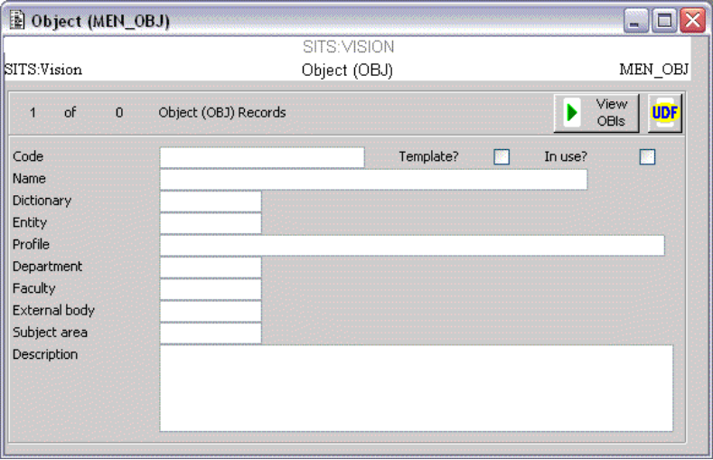

A Description field and 9 User Defined Fields (UDF) are available for holding more information.

Field | Name | Description
OBJ_CODE | Code | Object code | Primary Key
OBJ_NAME | Name | Full name
OBJ_TMPL | Template? | Determines whether the OBJ and associated records form a “template” process, which can be used to create new processes. Template OBJ processes are not processed by the OBJECT_CHECK POG, which checks Object Triggers and carries out the appropriate actions.
OBJ_IUSE | In Use? | In use? Y/N
OBJ_DCTC | Dictionary | Dictionary (DCT) code. This field is validated by an entry in the Uniface Dictionary (DCT) table.
OBJ_ENTC | Entity | Entity (ENT) code. This field is validated by an entry in the Entity (ENT) table.
OBJ_PRFL | Profile | Retrieve profile for the object.
OBJ_DPTC | Department | Department (DPT) code. This field is validated by an entry in the Department (DPT) table.
OBJ_FACC | Faculty | Faculty (FAC) that is controlling the object review.
OBJ_EXTR | External body | External Body for the object review.
OBJ_SUBC | Subject area | Subject (SUB) area for the object review.
OBJ_DESC | Description | Review description

S2.2 OBJECT INSTANCE (OBi)

The Object Instance (OBI) table defines basic information about the process for the object. Each Object (OBJ) may have several instances (OBI); one for each occurrence of the process. However, it is often much easier to have only one OBI per OBJ in practice. This is particularly true when defining the Tasks for user interaction.

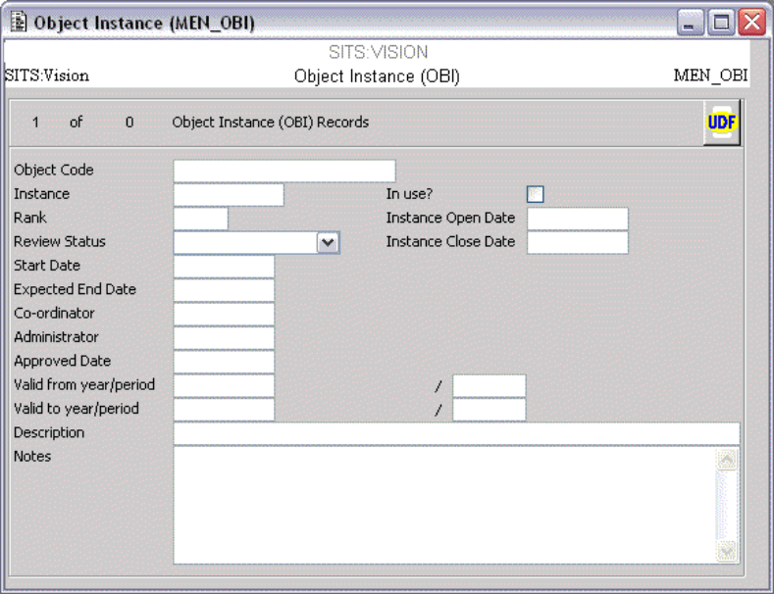

The key purpose of the OBI record is to define the parameters for the process, such as the open and close dates. It is also possible to link to an Academic Year (AYR) and Period Slot (PSL).

The Review Status can be used to withdraw or close a review, as this (in conjunction with Open and Close Dates) controls the trigger checking for the associated activities (this is covered later in the course).

A co-ordinator and administrator can be defined for the process, validated against Personnel (PRS) records. The Co-ordinator is important as this will be used as the sender of the messages delivered by Process Manager.

A Description field, Notes field and 9 User Defined Fields are available for holding other information.

The OBI code forms part of the primary key on all related records, which allows multiple processes to exist for a single OBJ, for example for different occurrences of a review.

Field | Name | Description
OBI_OBJC | Object Code | Object code | Primary Key
OBI_CODE | Instance | Instance code | Primary Key
OBI_IUSE | In use? | In use? Y/N
OBI_RANK | Rank | Rank
OBI_OPND | Instance Open Date | Instance Open Date
OBI_CLSD | Instance Close Date | Instance Close Date
OBI_STAS | Review Status | Review Status. Valid values are:  N Not started / Planning  R Rejected  A Approved  P Provisional  C Current  W Withdrawn
OBI_BEGD | Start Date | Review start date
OBI_ENDD | Expected End Date | Review end date
OBI_PRS1 | Co-ordinator | Co-ordinator (PRS) code. This field is validated by an entry in the Personnel (PRS) table.
OBI_PRS2 | Administrator | Administrator (PRS) code. This field is validated by an entry in the Personnel (PRS) table.
OBI_APPD | Approved Date | Date of approval.
OBI_AYR1 | Valid from year | Year from which the OBI is valid
OBI_PSL1 | Valid from period | Period from which the OBI is valid
OBI_AYR2 | Valid to year | Year to which the OBI is valid
OBI_PSL2 | Valid to period | Period to which the OBI is valid
OBI_DESC | Description | Review description
OBI_NOTE | Notes | Notes

S2.3 OBJECT PARTICIPANTS (OBP)

The participants in a process are defined in terms of the various roles required. The roles for each process can be defined to replicate the institutional positions as required. For example, within a Module Approval process there may be several different roles that may be filled by individuals or groups, such as a Review Board, Head of Department and Dean of Faculty. Whilst the roles required would be the same for each occurrence, the people taking those roles may not be. It is therefore possible to assign these roles dynamically when the process is initiated, or interactively as part of the process.

Participants can be Students (STU), Academic Personnel (PRS), Administrators (USR), Personnel Collections (PRC) or External Examiners (EEX). Participants can also be taken from the Master (MST) table.

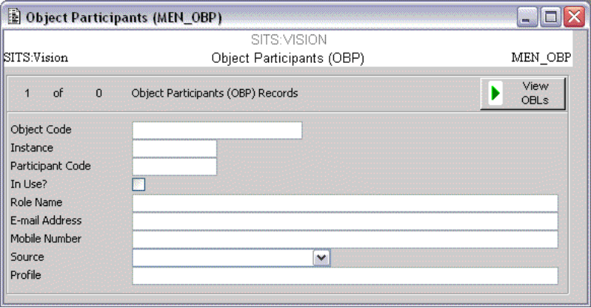

The person(s) to which the OBP record is linked is defined in the Profile field, for example stu_code=9002623 for a student with code 9002623.

OBP records are important as these are used for the delivery of messages to the people involved.

Field | Name | Description
OBP_OBJC | Object Code | Object (OBJ) code. | Primary Key
OBP_OBIC | Instance | Object Instance (OBI) code. | Primary Key
OBP_CODE | Participant Code | A code to identify the participant. | Primary Key
OBP_IUSE | In Use? | In use? Y/N
OBP_ROLE | Role Name | The role of this participant in the review process.
OBP_EMAD | E-mail Address | E-mail address for the participant.
OBP_NTEL | Mobile Number | Mobile phone number of the participant, for SMS text messages.
OBP_ENTC | Source | The entity (ENT) code for the participant to be located.
OBP_PRFL | Profile | The retrieve profile to retrieve the participant details.

S2.4 OBJECT RESOURCE (OBR)

Many processes have documents and other information associated with them. These can be stored as Resources for the process, and delivered as attachments with an activity task; for example procedure documents or help information can be sent.

Data collected through a task can also be stored in Resource records. This allows triggers to be evaluated against a response and different activities initiated as appropriate. Furthermore, responses can be viewed and also reported upon at various stages in the process.

The Object Resource (OBR) table is the repository for all the information and documents for the process. Each record defines a section of the process document or information that is used as a reference i.e. not part of the process document. The records are ranked to determine their appearance of the section within the overall document. The purpose of dividing the review document into sections is to enable the whole process to be organised into manageable components.

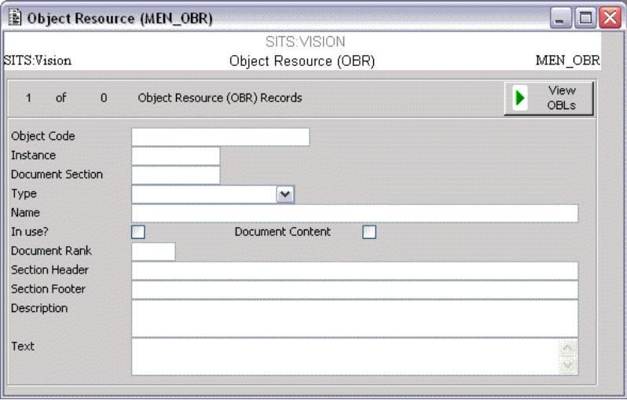

Resources can be delivered with a message by specifying the appropriate OBR code on the Object Activity (OBA) record, where the OBR Type is Link.

The use of the “Variable” type of OBR is recommended where a OBR record is being used as a “status” flag for triggering activities, and the Text type where data is being collected for use later in the process (for example when creating a new module).

Field | Name | Description
OBR_OBJC | Object Code | Object Code | Primary Key
OBR_OBIC | Instance | Instance | Primary Key
OBR_CODE | Document Section | Section number of the document. The review document can be divided into sections to enable specific activities (OBA) to be assigned for it. | Primary Key
OBR_TYPE | Type | Type. Each document section can be sourced from the following types:  L Link - a path to an internal file or document  T Text - text to be output  W Web content - HTML content or an URL to external document  V Variable - stores data that can be referenced or updated in the process
OBR_NAME | Name | Full name
OBR_IUSE | In use? | In use? Y/N
OBR_DCON | Document Content | Document content, Y/N. Indicates whether this section is part of the review document. This field can be useful when selecting records in a OBR list within a standard letter.
OBR_RANK | Document Rank | Rank
OBR_SHDR | Section Header | Section Header. If this section is part of the document content, this specifies the header to appear before the text for this section
OBR_SFTR | Section Footer | Section Footer. If this section is part of the document content, this specifies the text to appear after the text for this section
OBR_DESC | Description | Description
OBR_TEXT | Text | If the document type is Link, then this should be the path to the file/document.  If the document type is Text then this should be the text of the section.  If the document type is SRL then this should be the profile to retrieve the SRL record.  If the document type is Variable then this is where the value is held.  If the document type is Web content then this should be the HTML or the URL link to an external document.

S2.5 OBJECT ACTIVITY (OBA)

Events and Activities that need to take place as part of the process can be configured using Task Manager, and delivered to the appropriate participant or groups of participants on specific dates or conditionally upon completion of another activity. Relevant documents and resources can be linked to the activity and delivered with the task.

The Object Activity (OBA) table permits users to define a timetable of individual tasks that must be completed as part of the overall planning and approval process.

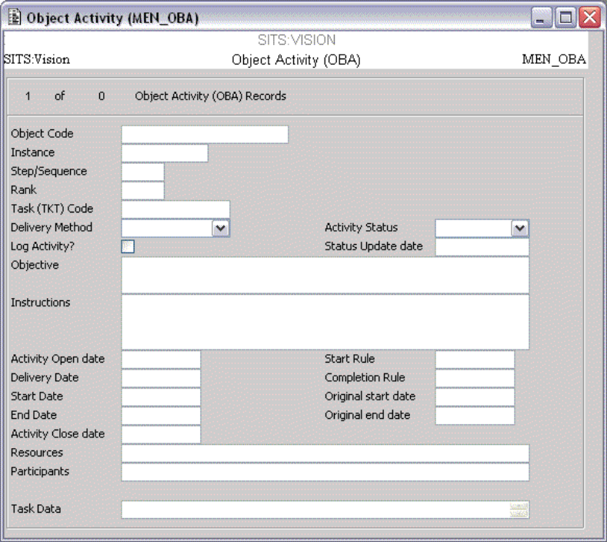

Open, Close, Start, Delivery and End dates can also be defined. These are important for the Object Activity Triggers (OBT) which are covered later.

The message is delivered to all participants (OBP) defined in the Participants field on the OBA record, using the Delivery Method specified (this can be e-mail, SMS message or intray (task) message). If user interaction is required, for example data must be provided, then the delivery method should be “Task Message” and a Task (TKT) code should be specified. The creation of Tasks is covered in SITS:Vision Training Course SVT604 Intray Messaging.

Any resources (OBR) defined on the OBA record can be delivered to the participant’s intray, where the Delivery Method is “Task Message” and the OBR type in “Link”.

Field | Name | Description
OBA_OBJC | Object Code | Object (OBJ) code. | Primary Key
OBA_OBIC | Instance | Object Instance (OBI) code. | Primary Key
OBA_SEQN | Step/Sequence | Step number of the activity. This number increases by 1 for every new step created. | Primary Key
OBA_RANK | Rank | Rank
OBA_TKTC | Task (TKT) Code | Task code. This is validated by an entry in the Task Type (TKT) table.
OBA_DLVM | Delivery Method | The method employed to deliver the activity to the recipient. Valid delivery methods are:  - E-mail – e-mail instruction and document sections to participants  - SMS – send the instruction and the document as SMS message/text to the participants  - Task Message – creates a task in the task messaging system for participant. The instruction is to be set-up as the message.
OBA_LOGA | Log Activity? | Indicates whether this activity is to be logged.
OBA_STAS | Activity Status | Indicates the status of this activity. Valid status values are:  - C - Completed  - S - Started  - N – Not started
OBA_UPDD | Status Update date | Indicates when the activity status was updated.
OBA_OBTV | Objective | Description of the objective.
OBA_INTR | Instructions | Instruction to the user. If the delivery mode is e-mail then this is the e-mail message. If the delivery mode is SMS, then this is the SMS message. If the delivery mode is task, then this is the message for the task. The task program is described in the task type (TKT).
OBA_OPND | Activity Open Date | The open date for the activity and trigger checking process.
OBA_DLVD | Delivery Date | The date to deliver the OBA message to the participants.
OBA_BEGD | Start Date | Start date of the activity for trigger-checking purposes.
OBA_ENDD | End Date | End date of the activity for trigger-checking purposes.
OBA_CLSD | Activity Close Date | The close date for the activity and trigger checking process.
OBA_STTR | Start Rule | Start Rule.
OBA_COMR | Completion Rule | Conditions that must be met for the activity to be completed, for example when 75% of participants have responded.
OBA_OSTD | Original Start Date | The original start date for the activity.
OBA_OEND | Original End Date | The original end date for the activity.
OBA_SECT | Resources | Object resources (OBR) associated with the activity.
OBA_OBPN | Participants | Object participants (OBP) associated with the activity.
OBA_TSKD | Task Data | Data about the status of tasks.

S2.6 OBJECT ACTIVITY TRIGGER (OBT)

Initiation of activities and delivery of tasks is controlled by Activity Triggers, which are checked automatically at regular intervals, or optionally this can be done interactively. Triggers can be configured to start activities, update a resource, update data or send an e-mail or SMS text message. This makes it possible to send reminder messages if a participant has not completed their task, or deliver a notification that an activity has been completed.

Triggers can be conditional upon date ranges, the outcome of previous activities or the status of other records.

The Object Activity Trigger (OBT) table contains the trigger processing required for each step in the Object Activity (OBA).

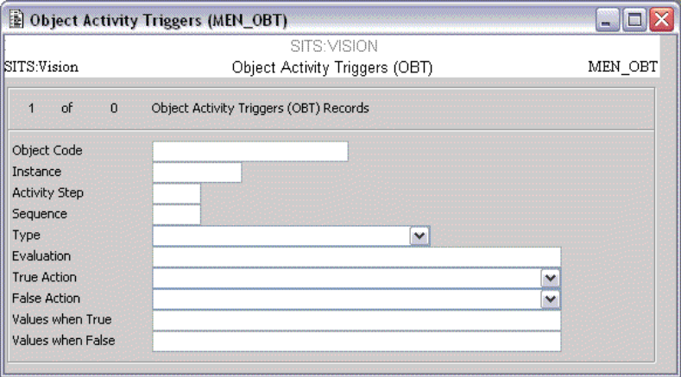

Field | Name | Description
OBT_OBJC | Object Code | Object (OBJ) code. | Primary Key
OBT_OBIC | Instance | Object Instance (OBI) code. | Primary Key
OBT_OBAS | Activity Step | Step number of the activity. This number increases by 1 for every new step created. | Primary Key
OBT_SEQ6 | Sequence | Record sequence number. This allows more than one trigger of the same type. | Primary Key
OBT_TTYP | Type | Trigger type. Valid values are:  1 – Before delivery date  2 – On delivery date  3 – Between delivery and start dates  4 – On start date  5 – Between start and end dates  6 – On end date.  7 – After end date  8 – On task response.
OBT_EVAL | Evaluation | The evaluation text for processing the condition. Multiple conditions can be linked with the & symbol (and) and the | (or) symbol.
OBT_ACTT | True Action | Action type when true. See below for a list of valid action types.
OBT_ACTF | False Action | Action type when false. See below for a list of valid action types.
OBT_VALT | Values when True | The parameter values necessary for the action when evaluation is true.
OBT_VALF | Values when False | The parameter values necessary for the action when evaluation is false.

Valid action types are:

• Initiate activity
• Go to step
• Change data
• Update resource
• Set to started and updated date to today
• Set to complete and updated date to today
• Set to not yet started and updated date to today
• E-mail a message.
• Send SMS text

The most common types of Trigger are:

S2.6.1 UPON COMPLETION OF ANOTHER ACTIVITY

The syntax for this is COMPLETEDACTIVITY=NNNN
(where NNNN is the sequence number of the appropriate OBA record)

These can be linked, e.g.

COMPLETEDACTIVITY=0001&COMPLETEDACTIVITY=0002

This would check that both OBAs 0001 and 0002 have been completed.

COMPLETEDACTIVITY=0001|COMPLETEDACTIVITY=0002

This would check to see if either OBA 0001 or 0002 have been completed.

S2.6.2 WHEN THE VALUE OF A RECORD IS A CERTAIN VALUE

The syntax for this is ‘<<SRL_EXPRESSION>>’=’VALUE’
(where <<SRL_EXPRESSION>> is SRL code use to retrieve the appropriate field value, and VALUE is the value to be compared).

To check against the value of an OBR with the code STATUS_1 (and look for a value of Y) the code would be:

'<<<OBA_OBJC>·;<OBA_OBIC>·;STATUS_1&GOBR_TEXT.OBR.MENSYS>>'='Y'

This passes in the OBJ code, the OBI code and the code of the OBR to search for, then retrieves the OBR record and gets the value of the OBR text field, then compares this to a value of Y.

In all of these examples, the code given should be used in the “Evaluation” field on the OBT record.

When using triggers to deliver activities (OBA), the trigger should be attached to the appropriate OBA and the True Action should be “Initiate Activity”. It is recommended that another identical OBT is created for the same OBA, but with a True Action of “Set to started and updated date to today”. This will update the OBA record and prevent it from being initiated again.

S2.7 OBJECT LOGS (OBL)

The Object Activity Log (OBL) table logs the outcome of Object Activities (OBA), including data on task completion, date and time.

Object Log (OBL) records are created when Object Activities (OBA) are completed if the “Log Activity?” field on the OBA record is ticked.

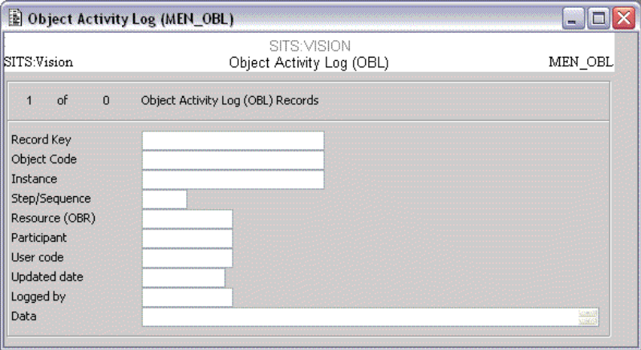

Field | Name | Description
OBL_CODE | Record Key | A time-based primary key | Primary Key
OBL_OBJC | Object Code | Object (OBJ) code
OBL_OBIC | Instance | Object Instance (OBI) code
OBL_OBAS | Step/Sequence | The step number in the activity timetable
OBL_OBRC | Resource (OBR) | Object resource (OBR) to which this log relates
OBL_OBPC | Participant | Object participant (OBP) codes to which this step relates
OBL_MSTC | User Code | The user who activated this step
OBL_UPDD | Updated Date | Updated date
OBL_LOGB | Logged by | The user who logged this step
OBL_DATA | Data | The data processed by the step.

S2.8 OBJECT OVERVIEW (OBO)

The Object Overview (OBO) screen provides the user with a means of reviewing the status of a process within the client server application. The data in the top section of the screen relates to the Object Instance (OBI) and may be edited (excluding Primary Key fields).

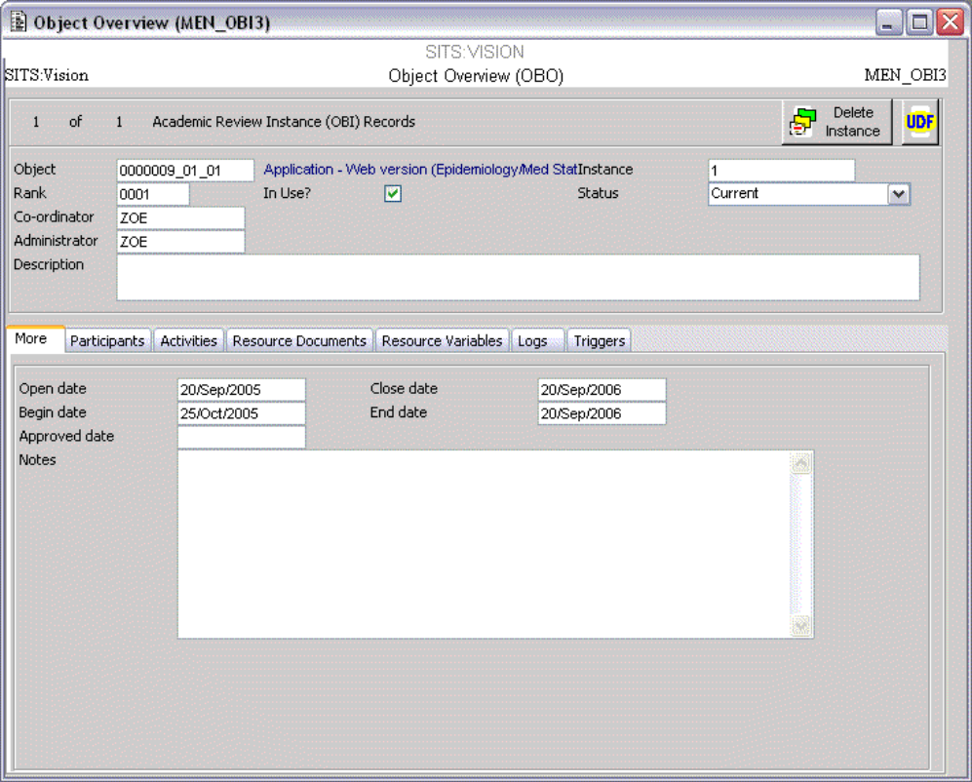

The tabs in the bottom section allow the user to view the Participants (OBP), Activities (OBA), Triggers (OBT), Resources (OBR) and Logs (OBL) associated with the Object Instance (OBI). These may be edited where applicable via the buttons on each tab.

The “Delete Instance” button can be used to delete all records associated with the OBI (excluding OBJ).

SESSION 3

The topics in this session are:

3.1 Template Processes
3.2 Replicating Template Processes
3.3 Triggering Processes

S3.1 TEMPLATE PROCESSES

To gain the most benefit from Process Manager, it is recommended that reusable “template” processes are set up, and used as the basis for “live” processes.

This reduces the amount of manual setup that is required each time a review occurs. A new live process can be created based upon the template process, replicating the OBJ, OBI, OBA, OBT, OBP and OBR records.

The exercise below will set up a simple process to change a module title.

Exercise 3.1.1 – Setting up a template process - OBJ

1 Select OBJ - Object

2 Enter MOD_TITLE_XX in the ‘Object code’ field (where XX is your initials)

3 Enter Module Title Change Process in the ‘Name’ field

4 Enter CAMS in the ‘Dictionary’ field, and MOD in the ‘Entity Field’

5 Tick the ‘Template’ field.

6 [Store]

Your OBJ record should look like this:

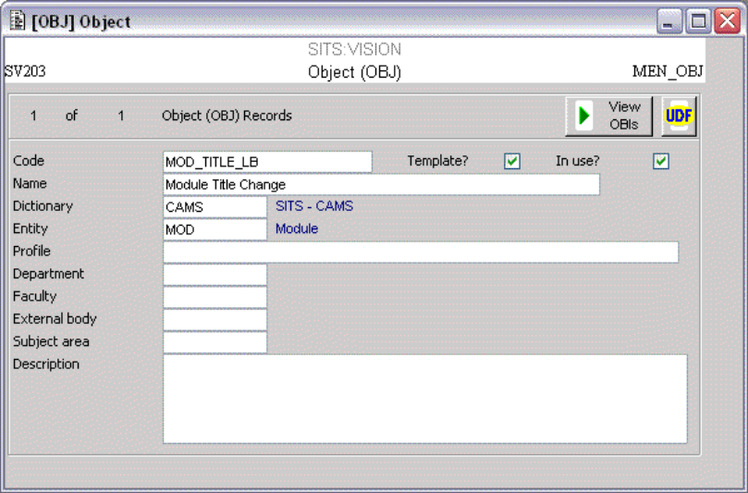

Exercise 3.1.2 – Setting up a template process - OBI

1 Click the ‘View OBIs’ button to access OBI – Object Instance

2 ‘Object Code’ should be automatically populated. Enter 1 in the ‘Instance’ field and also in the ‘Rank’ field

3 Select Current from the ‘Review Status’ drop down

4 You can leave the various dates and the ‘Co-ordinator’ and ‘Administrator’ fields blank, as these will be populated dynamically later on the new “live” records.

5 [Store]

Your OBI record should look like this:

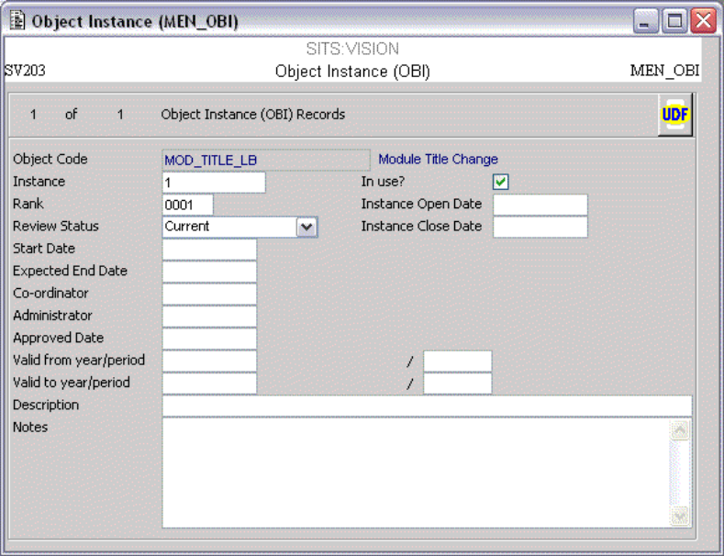

Exercise 3.1.3 – Setting up a template process - OBP

1 Select [Other] > [Participants] to access OBP – Object Participants

2 ‘Object Code’ and ‘Instance’ should be automatically populated. Enter INITIATOR in the ‘Participant Code’ field.

3 Enter Initiator - person starting the process in the ‘Role Name’ field.

4 Select Personnel (PRS) from the ‘Source’ dropdown.

5 [Store]

6 Select [File] > [Add]

7 Enter MOD_TITLE_XX in ‘Object code’ field (where XX is your initials)

8 Enter 1 in the ‘Instance’ field

9 Enter REVIEWER in the ‘Participant Code’ field

10 Enter Person reviewing the changes in the ‘Role Name’ field

11 Select Personnel (PRS) from the ‘Source’ dropdown. It is important that this is populated.

12 [Store] and [Quit]

Your OBP records should look like this:

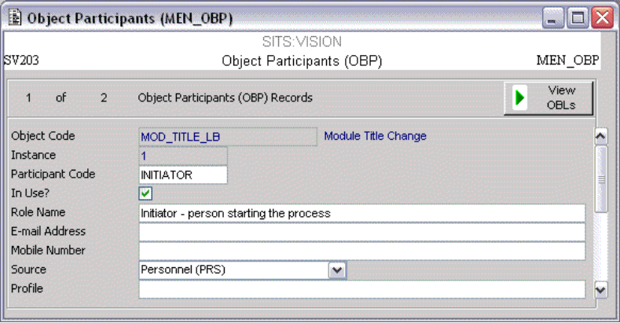

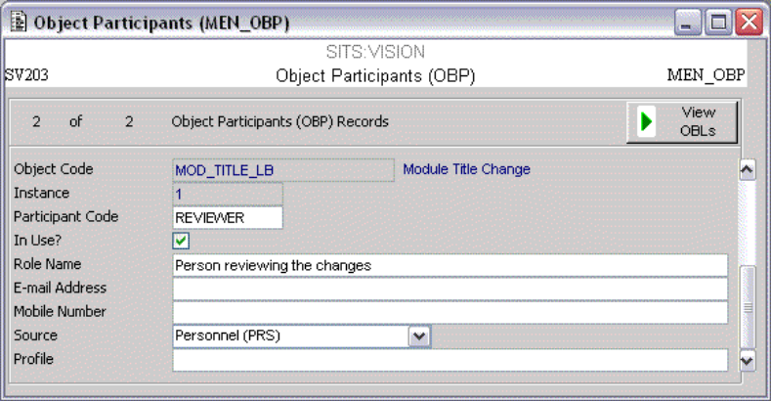

Exercise 3.1.4 – Setting up a template process - OBR

1 Whilst on the OBI screen, select [Other] > [Resources] to access OBR – Object Resources

2 ‘Object Code’ and ‘Instance’ should be automatically populated. Enter NEW_TITLE in the ‘Resource Code’ field.

3 Select Text from the ‘Type’ dropdown

4 Enter Proposed Module Title in the ‘Resource Name’ field.

5 [Store]

6 Select [File] > [Add]

7 Enter MOD_TITLE_XX in ‘Object code’ field (where XX is your initials)

8 Enter 1 in the ‘Instance’ field

9 Enter APPROVAL in the ‘Resource Code’ field.

10 Select Variable from the ‘Type’ dropdown

11 Enter Approval Status in the ‘Resource Name’ field.

12 [Store] and [Quit]

Your OBR records should look like this:

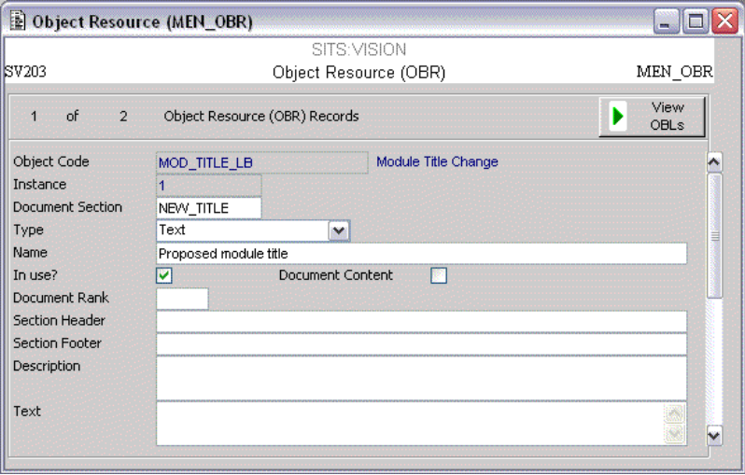

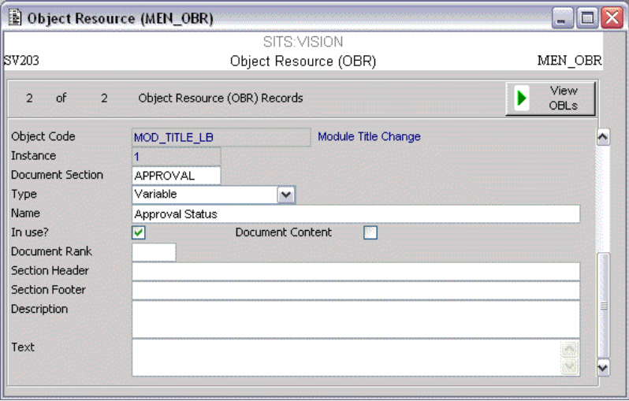

Exercise 3.1.5 – Setting up a template process - OBA

1 Whilst on the OBI screen, select [Other] > [Activities] to access OBA – Object Activities

2 ‘Object Code’ and ‘Instance’ should be automatically populated, along with ‘Step / Sequence’

3 Enter 0001 in the ‘Rank’ field

4 Enter PM_TRAIN_1 in the ‘Task (TKT) Code’ field

5 Select Task Message from the ‘Delivery Mode’ dropdown

6 Select Not Started from the ‘Activity Status’ dropdown

7 Enter the text Module Title Change in the ‘Objective’ field

8 Enter the text Please carry out the task attached to propose a Module Title Change in the ‘Instructions’ field

9 Enter INITIATOR in the ‘Participant’ field.

10 The dates can be let blank as these will be populated dynamically on the live records

11 [Store]

12 Select [File] > [Add]

13 Enter MOD_TITLE_XX in ‘Object code’ field (where XX is your initials)

14 Enter 1 in the ‘Instance’ field

15 Enter 0002 in the ‘Step / Sequence’ and ‘Rank’ fields, and set up the rest of the fields as show below (‘Task code’ = PM_TRAIN_2, ‘Participant’ = REVIEWER) and [Store]

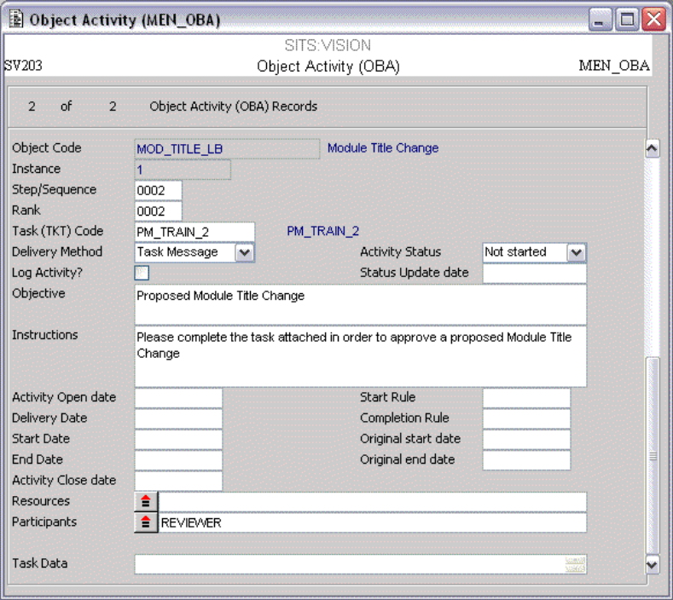

Exercise 3.1.5 (continued) – Setting up a template process – OBA

16 Select [File] > [Add]

17 Enter MOD_TITLE_XX in ‘Object code’ field (where XX is your initials)

18 Enter 1 in the ‘Instance’ field

19 Enter 0003 in the ‘Step / Sequence’ and ‘Rank’ fields, and set up the rest of the fields as show below (‘Participant’ = INITIATOR) and [Store] then [Quit].

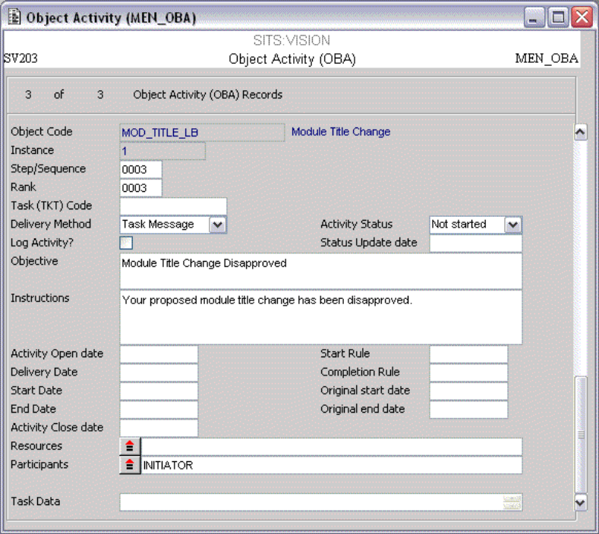

When setting up template processes, it is important that the Activity Status is set to “Not Started” and that at least one Participant (OBP) is defined. Also, the Delivery Method must be specified.

Exercise 3.1.6 – Setting up a template process - OBT

1 Close any open screens, then access OBO

2 Enter MOD_TITLE_XX in ‘Object’ field (where XX is your initials)

3 Enter 1 in the ‘Instance’ field

4 [Retrieve]

5 The data set up previously is viewable on each tab. Select the ‘Activities’ tab.

6 Click the green ‘Trig’ button next to the first activity to access OBT – Object Activity Triggers

7 The first 4 fields should be automatically populated. Select 5 – Between Start and End Dates from the ‘Type’ drop down.

8 Select Initiate Activity from the ‘True Action’ dropdown

9 [Store]

10 Select [File] > [Release] to release the OBT record. Check the message line.

11 On the new record, amend the ‘Sequence’ to 000002

12 Select Set to started and updated date to today from the ‘True Action’ dropdown.

13 [Store] and [Quit]

14 Click the green ‘Trig’ button next to the second activity. Set up a new OBT record like the one below (‘Evaluation’ = COMPLETEDACTIVITY=0001)

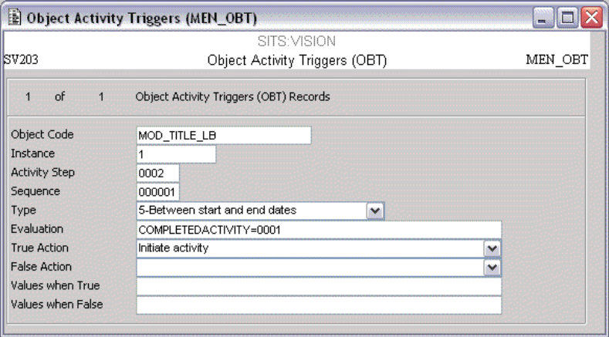

Exercise 3.1.6 (continued) – Setting up a template process - OBT

15 Select [File] > [Release]

16 On the new record, amend the ‘Sequence’ to 000002

17 Select Set to started and updated date to today from the ‘True Action’ dropdown.

18 [Store] and [Quit]

The new record should look like this:

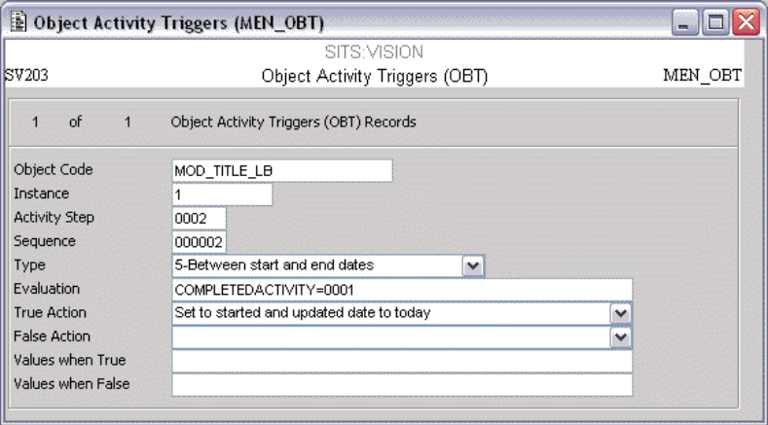

Exercise 3.1.6 (continued) – Setting up a template process - OBT

19 Click the green ‘Trig’ button next to the second activity. Set up a new OBT record like the one below. The ‘Evaluation’ field should be set to:

'<<<OBA_OBJC>·;<OBA_OBIC>·;APPROVAL&GOBR_TEXT.OBR.MENSYS>>'='Y'

Please note that ·; is the ‘gold’ semi-colon character.

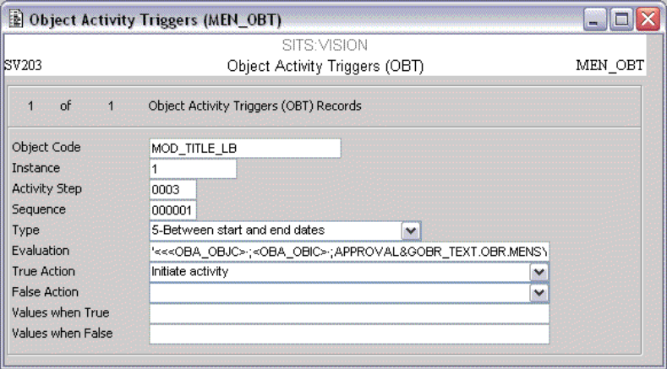

Exercise 3.1.6 (continued) – Setting up a template process - OBT

20 Select [File] > [Release]

21 On the new record, amend the ‘Sequence’ to 000002

22 Select Set to started and updated date to today from the ‘True Action’ dropdown.

23 [Store] and [Quit]

The new record should look like this:

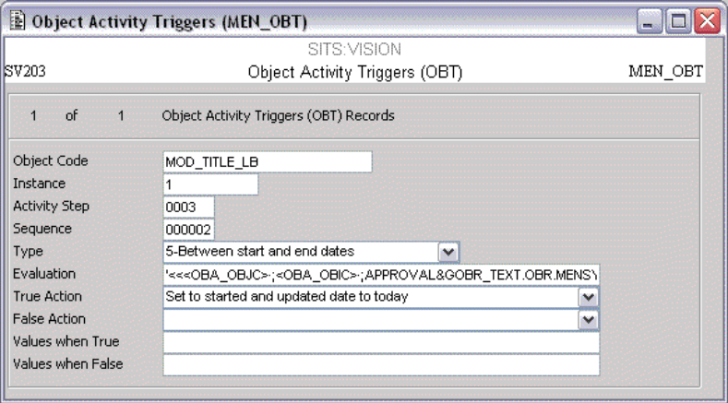

The template process is now complete, but it must be replicated to produce the live process, which must also be triggered to start the process moving.

S3.2 REPLICATING TEMPLATE PROCESSES

S3.2.1 GENERATE OBJ

To replicate a template process and create a live process, an operation can be run. The easiest way to do this is through a standard letter (SRL) (SITS:Vision training courses SVT109 and 110) via the &P format. The syntax required is as follows:

<<P01=OBJ·;P02=New OBJ code·;P03=Template OBJ code·;P04=New OBI·;P05=Template OBI·;P06=Entity for OBJ·;P07=Profile for OBJ·;P08=&PMEN_YOBJ.GENERATE_OBJ·;P02>>

This can be broken down into the individual parameters:

P01 – this determines the “top” entity to replicate and is most commonly OBJ
P02 – this defines the new OBJ code
P03 – this is the template OBJ to be used
P04 – this defines the new OBI code
P05 – this is the template OBI to be used
P06 – this defines the ‘Entity’ for the OBJ record
P07 – this defines the ‘Profile’ for the OBJ record
P08 – this parameter can be used as a date modifier. A value of -1 will make all dates relative to today’s date

It is possible to use SRL-style variables in any one of the parameters, but since these will be fields within a field (variable), they should be surrounded by single angle brackets, e.g.

<MOD_CODE.MOD>

So to create a new live process that has an OBJ code built from Module code and date / time, the value of P02 would be <MOD_CODE.MOD>_<$date&DD2M2Y2>_<$time&DH2N2>

The reason for appending date and time is to ensure that a unique OBJ code is created each time.

The code below would generate a new live process with the OBJ code built in the way above, using the MOD_TITLE_XX (where XX is your intitials) process set up previously.

<<P01=OBJ·;P02=<MOD_CODE.MOD>_<$date&DD2M2Y2>_<$time&DH2N2>·;P03=MOD_TITLE_XX·;P04=1·;P05=1·;P06=MOD·;P07=<MOD_CODE.MOD>·;P08=&PMEN_YOBJ.GENERATE_OBJ·;P02>>

S3.2.2 DMU UPDATES

It will also be necessary to update some records, such as Object Instance (OBI) and Activities (OBA); for example to populate the date fields dynamically based around today’s date. This can be done in the same standard letter (SRL) through a DMU update.

The syntax for this is as follows:

<<P01=(action)·;P02=(switches)·;P03=(dctc)·;P04=(entc)·;P05=(progname)·;P06=(infields)·;P07=(outfields)·;P08=(hits)&PMEN_YDMU.ACTION·;P08>>

The parameters can be broken down as follows:

P01 – Action. This can be actions such as ADD or DELETE, but is most commonly UPDATE
P02 – Switches. This is most commonly used to auto-calculate sequence numbers when adding new records
P03 – Dictionary of the entity being used
P04 – Entity to be used
P05 – Program. This can be used to override the default program used for editing the entity but is not recommended.
P06 – The retrieval criteria to get the appropriate record
P07 – Fields to be updated and new values
P08 – Record numbers to be affected. A value of -1 will use all records retrieved by the criteria is P06

So, to update the dates on an OBA record, the code is:

<<P01=UPDATE·;P02=·;P03=MENSYS·;P04=OBA·;P05=·;P06=OBA_OBJC=<MOD_CODE.MOD>_<$date&DD2M2Y2>_<$time&DH2N2>·!·;OBA_OBIC=1·;P07=OBA_OPND=<$date&D-1D>·!·;OBA_BEGD=<$date&D-1D>·!·;OBA_BEGD=<$date&D-1D>·!·;OBA_ENDD=<$date&D+1Y>·!·;OBA_CLSD=<$date&D+1Y>·;P08=-1&PMEN_YDMU.ACTION·;P08>>

This will update all OBA records for the new process as follows:

Open Date and Start Date - yesterday’s date (this is to enable our triggers to be processed)
End Date and Close Date – one year from today’s date

A similar DMU update could be used to update the Open and Close date on the OBI record. It is also important to have a DMU update that populates the Co-ordinator and Administrator fields on the OBI records as messages cannot be delivered without this. If the letter is being run from e:Vision, these fields could be set to <$$prs_code>, which is the PRS code of the person logged in.

Alternatively they could be populated on the template OBI and this would negate the need to update them via DMU.

S3.2.3 UPDATE PARTICIPANTS

Another operation makes it possible to update Participant (OBP) records. This is useful as the participants for each process are likely to be different, and they can therefore be built using SRL-style expressions as appropriate. The syntax for this operation is:

<<P01=OBJ code·;P02=OBI code·;P03=OBP code·;P04=Profile for OBP·;P05=&PMEN_YOBP.UpdateParticipant·;P04&L0>>

The parameters are broken down as follows:

P01 – The OBJ code being used
P02 – The OBI code being used
P03 – The OBP code of the participant to be updates
P04 – The profile for retrieving the appropriate record. This will depend upon the Source of the OBP. For example, if the Source is “Personnel (PRS)”, the Profile would be prs_code=CODE (where CODE is a value in the PRS table). Likewise it the Source was “Student (STU)”, the Profile would be stu_code=NNNNN (where NNNNN is a STU code)
P05 – not used

So to update the INITIATOR Participant (OBP) to the PRS code of the person running the letter (the person starting the process), the code is as follows:

<<P01=<MOD_CODE.MOD>_<$date&DD2M2Y2>_<$time&DH2N2>·;P02=1·;P03=INITIATOR·;P04=prs_code=<$$prs_code>·;P05=&PMEN_YOBP.UpdateParticipant·;P04&L0>>

Please note that this will only work if the letter is run in the e:Vision web portal, as it relies upon <$$prs_code> to determine the PRS code of the person logged in.

S3.3 TRIGGERING PROCESSES

Once a template process has been replicated to create a new live process, it is also necessary to check the triggers (OBT) for the new process. This enables activities to be started as appropriate.

Another operation can be performed in the same standard letter (SRL) that creates the new process in order to do this. The syntax is:

<<P01=OBJ code·;P02=OBI code·;P03=·;P04=·;P05=&PMEN_YOBT.CheckObjectTriggers·;P01>>

So to check the triggers for the new live process set up previously, the code would be:

<<P01==<MOD_CODE.MOD>_<$date&DD2M2Y2>_<$time&DH2N2>·;P02=1·;P03=·;P04=·;P05=&PMEN_YOBT.CheckObjectTriggers·;P01>>

This would check against all the triggers for the new OBJ where the Activity (OBA) Open Date has passed and the OBA Close Date has not yet passed. The OBI Open and Close Dates are also used in order to determine whether any triggers should be checked.

Exercise 3.3.1 – Replicating and Triggering Processes

1 Log in to the e:Vision portal using an appropriate PRS code

2 Access the Process Manager Training container

3 Click the ‘Module Title Change (Training)’ link

4 Enter a Module (MOD) code and click ‘Run’

- The letter runs and a new process is created (reference number shown). Access the e:Vision intray.

- Carry out the task attached and return to the intray to access a new message that has been delivered.

7 Carry out this new task. If the user approves the change, the MOD record is updated accordingly. If not, a message is sent informing the INITIATOR that the change has been disapproved.

SESSION 4

The topics in this session are:

4.1 Trigger Checking
4.2 Task Manager Interaction

S4.1 TRIGGER CHECKING

In addition to the trigger checking program that is run in the initial standard letter (SRL), there are 2 other ways of checking triggers (OBT) for a process. These are the OBJECT_CHECK POG (Program Option Group), and the MEN_YOBA program within a Task (TKT).

It is possible to check all triggers for all open Object Instances (OBI) by opening the Program Option Group (POG) screen and retrieving the OBJECT_CHECK record.

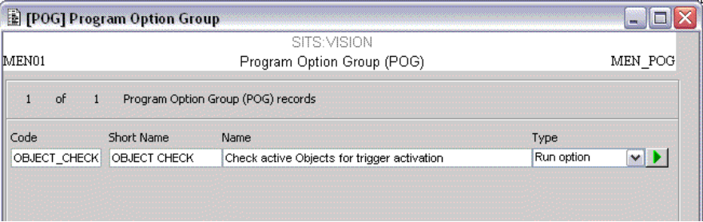

Clicking the green run button accesses a screen with the option to run the trigger checking process for all open OBIs. It is important to note that OBIs where the associated Object (OBJ) record is flagged as a “Template” are ignored by this process.

This could be set up as a batch job to run overnight if necessary.

S4.2 TASK MANAGER INTERACTION

S4.2.1 UPDATE OBA AND PROCESS TRIGGERS

At the end of a Task (TKT) it is important to run a program which updates the OBA record (for example to update the Activity Status to “Complete”) and also check the triggers for the process (for example to start subsequent activities).

This is done by creating a hidden step (TTE) at the end of the task which is of type “Program (PRA)”. The “PRA code” to be used is MEN_YOBA and the “Operation” is TASK, for example:

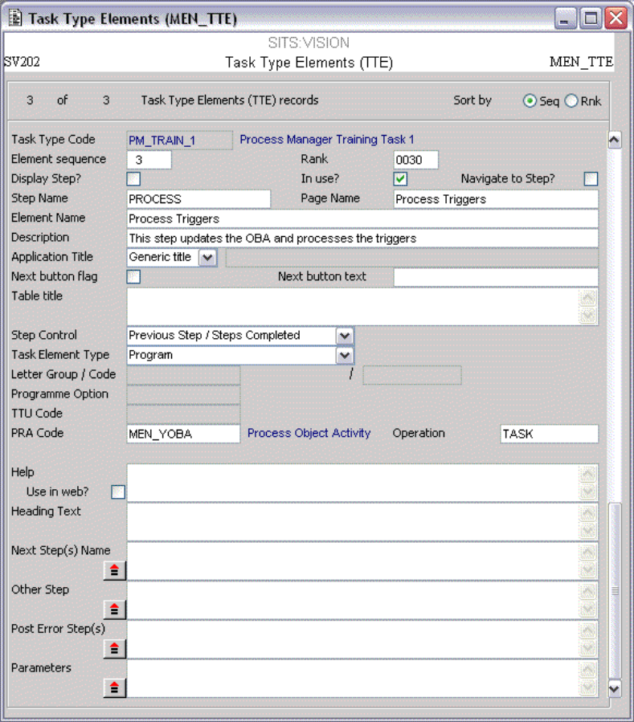

S4.2.2 UPDATING RECORDS

It is often necessary to update records, for example the Object Resource (OBR) records. This can be done using Task Table Updates (TTU) in the Tasks, but it is necessary to determine a retrieve profile to get the right records.

For example, to retrieve an OBR and update it, it is necessary to specify the Object (OBJ) code, the Object Instance (OBI) code and the OBR code itself.

Whilst the OBI and OBR code can be “hardcoded” into the update (as these are known), the OBJ code must be determined from elsewhere as the OBJ code will be different each time a new process is created.

When intray messages are delivered, a Message Header (MHD) record is created, which holds details of the date and time created, the person to whom the message was delivered, and the task associated. Where MHDs are created by Process Manager, the External Reference field on the MHD will hold the related OBJ code. This makes it possible to determine the correct OBJ code in a TTU and elsewhere within the Task as well.

The retrieve profile on a Task Update Definition (TUD) to update the NEW_TITLE Object Resource (OBR) would therefore be as follows (provided the new OBI code specified was 1):

OBR_OBJC=<<MHD_EREF.MHD>> ·; OBR_OBIC=1 ·; OBR_CODE=NEW_TITLE

SESSION 5

The topics in this session are:

5.1 Letters and Reporting

S5.1 LETTERS AND REPORTING

The Standard Letter Group (SLG) for Process Manager is OBI. This enables letters to be generated from both the Object Instance (OBI) and Object Overview (OBO) screens, and from within e:Vision.

This allows reports to be created upon data collected, for example reporting on data collected as part of an Online Module Evaluation process, or displaying data collected which is used to create a Module Proposal form.

To display data collected during the process which is held in OBR records, an OBR list should be used, for example:

[[OBR.MENSYS:SEL:OBR_CODE.OBR=”NEW_TITLE”: <<OBR_TEXT.OBR>>]]

More advanced facilities are available, such as counting the number of records matching certain criteria, or counting the number of unique values. Further information is available in SITS:Vision Training Course SVT110 Advanced Standard Letters.

Another feature of the OBI letter group is that it allows the user to create a fully customisable view of the status of a process, which can be viewed in client server and e:Vision. For example, a list of the activites (OBA), the participant attached and their status could be shown like this:

[[OBA.MENSYS:<<OBA_SEQN.OBA>> <<OBA_OBPN.OBA>> <<OBA_STAS.OBA>>]]

SESSION 6

The topics in this session are:

6.1 Removing Data

S6.1 REMOVING DATA

It may be necessary to remove the data for a process at any given time. The OBJ, OBI, OBP, OBR, OBA, OBT and OBL records can be deleted as normal in each table, but there is also a “Delete Instance” button on the Object Instance (OBI) screen.

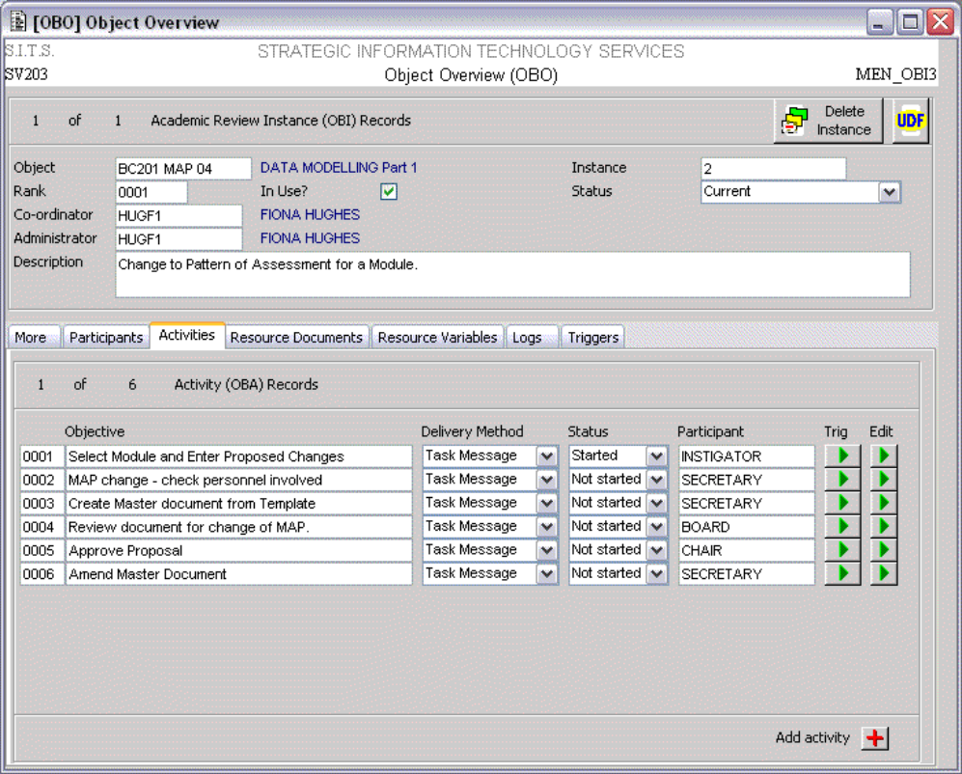

Clicking this button gives the following prompt:

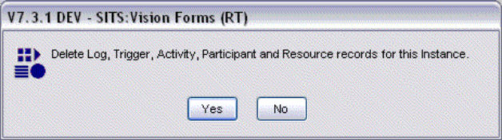

This will remove OBI, OBP, OBR, OBA, OBT and OBL data. The OBJ record will not be deleted – this can be deleted manually in the Object (OBJ) screen itself.

TABLE OF CONTENTS

PROCESS MANAGER 1
INTRODUCTION 1
COURSE TOPICS 1
COURSE STRUCTURE 1
SESSION 1 1
S1.1 COURSE INTRODUCTION 1
S1.2 WHAT IS PROCESS MANAGER? 1
SESSION 2 2
S2.1 THE OBJECT (OBJ) TABLE 2
S2.2 OBJECT INSTANCE (OBi) 4
S2.3 OBJECT PARTICIPANTS (OBP) 6
S2.4 OBJECT RESOURCE (OBR) 7
S2.5 OBJECT ACTIVITY (OBA) 9
S2.6 OBJECT ACTIVITY TRIGGER (OBT) 11
S2.6.1 UPON COMPLETION OF ANOTHER ACTIVITY 12
S2.6.2 WHEN THE VALUE OF A RECORD IS A CERTAIN VALUE 12
S2.7 OBJECT LOGS (OBL) 13
S2.8 OBJECT OVERVIEW (OBO) 14
SESSION 3 15
S3.1 TEMPLATE PROCESSES 15
S3.2 REPLICATING TEMPLATE PROCESSES 25
S3.2.1 GENERATE OBJ 25
S3.2.2 DMU UPDATES 25
S3.2.3 UPDATE PARTICIPANTS 26
S3.3 TRIGGERING PROCESSES 28
SESSION 4 29
S4.1 TRIGGER CHECKING 29
S4.2 TASK MANAGER INTERACTION 29
S4.2.1 UPDATE OBA AND PROCESS TRIGGERS 29
S4.2.2 UPDATING RECORDS 30
SESSION 5 31
S5.1 LETTERS AND REPORTING 31
SESSION 6 32
S6.1 REMOVING DATA 32
TABLE OF CONTENTS 33
SITS:VISION TRAINING COURSE EVALUATION FORM 34

SITS:VISION TRAINING COURSE EVALUATION FORM

The aim is to maintain and improve the quality of the training provided. In order to facilitate this could you please spare a few minutes of your time to complete the following evaluation form providing additional comments where appropriate.

Name (optional)
Institution
Course | SVT??? – Course Title
Course Tutor
Course Date

Please rate each of the following statements by ticking the relevant box:

Trainer Evaluation | Strongly  Agree | Agree | Disagree | Strongly  Disagree
The trainer delivered the course clearly and effectively.
The trainer had suitable knowledge of the subject.
The trainer was able to promote discussion and answer any questions.
Comments:
Course Evaluation
The course met its objectives.
The course was delivered at a suitable pace.
The training manuals and exercises supported the course effectively.
Comments:
Evaluation of the Learning Environment (where appropriate)
The teaching environment supported learning.
Comments:

s:\documents\training\stp\tribal training course template.doc

